Migration & Seeding Database Laravel

1. Buat Migration File

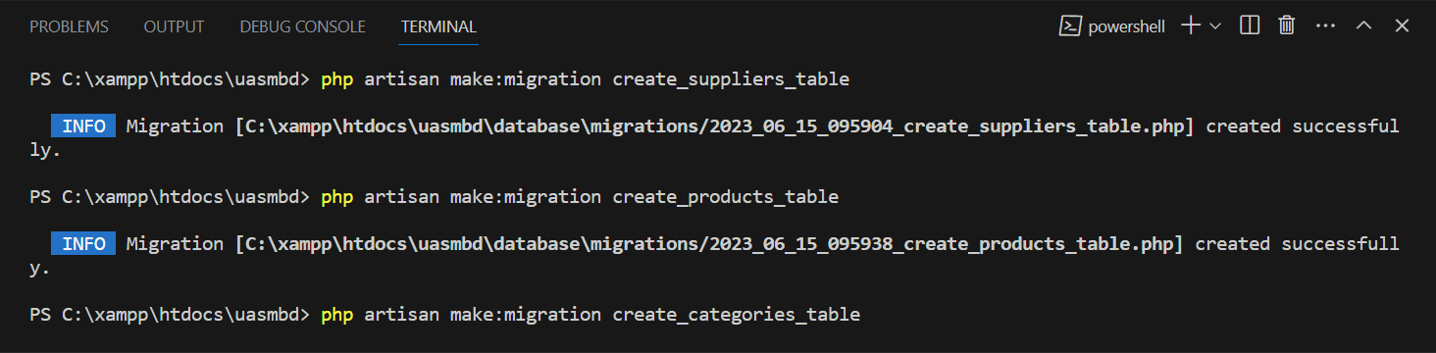

1. Edit File Migration

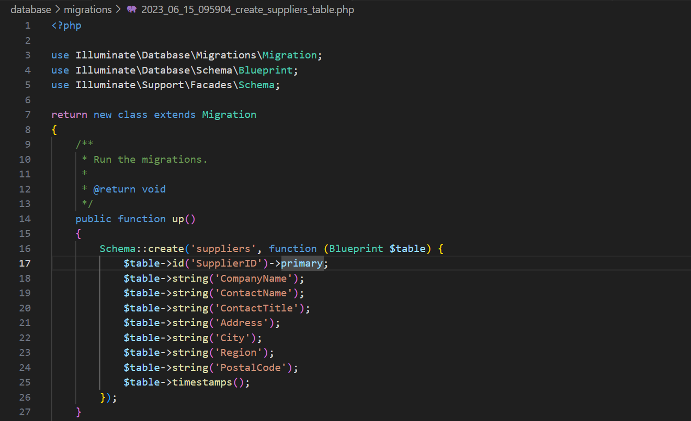

1. Migrate Database

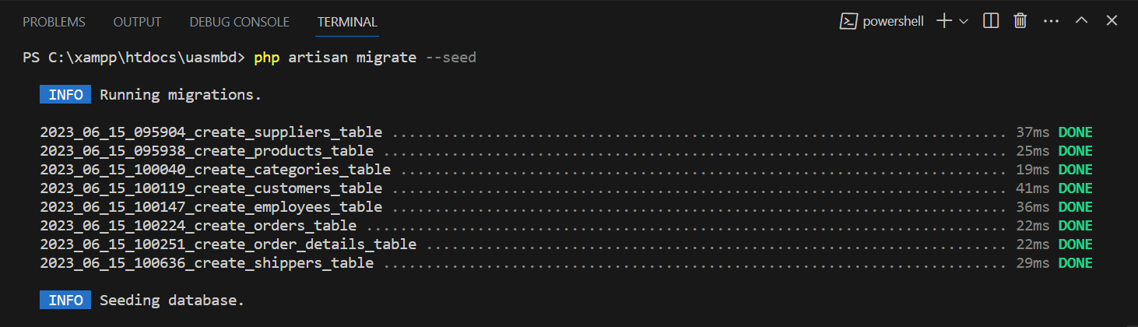

1. Buat Seeder File

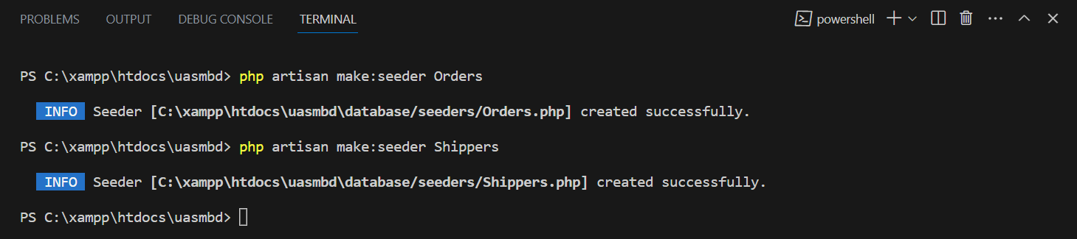

1. Edit File Seeder

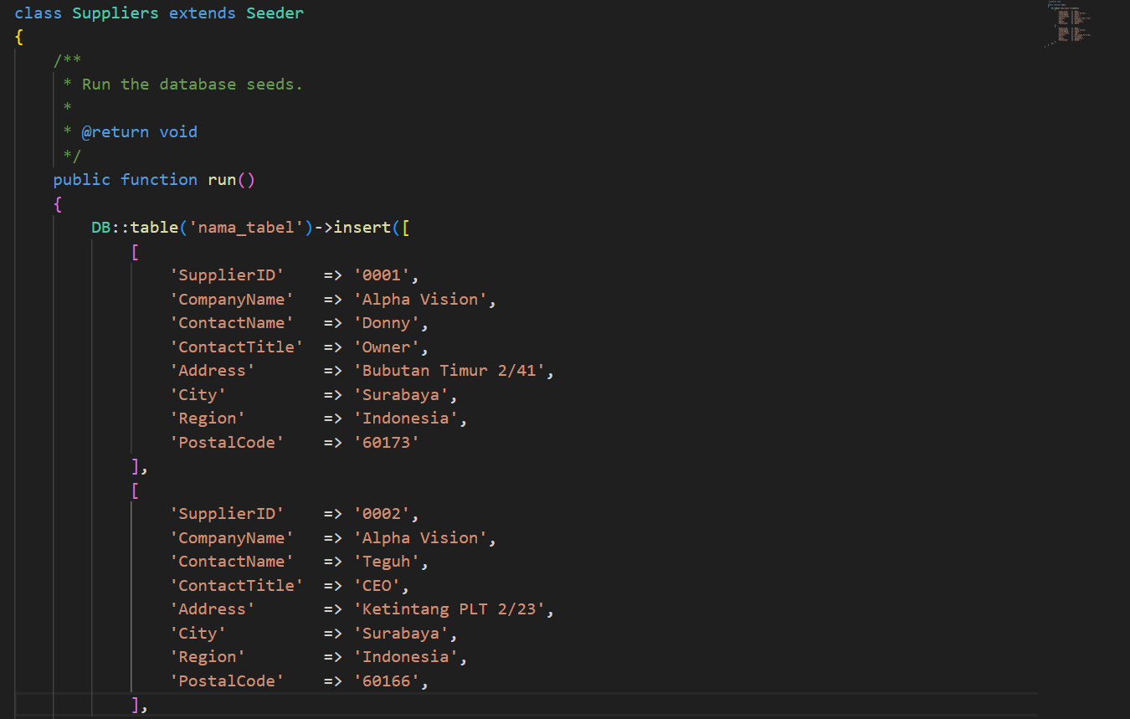

1. Seeder Isi Database

